September 2014 - June 2015
Simon Alexander Betts
HErefordshire and Ludlow college
Down Hill Soapbox Cart
Simon Alexander Betts

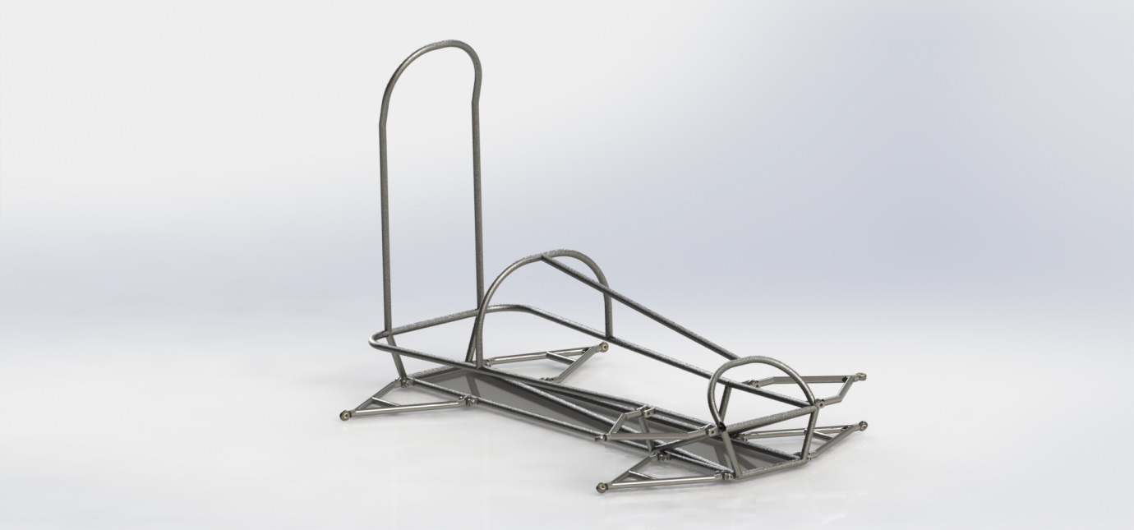

Contents
Summary  - The subject of the report  - What the report shows  - A synopsis of the conclusions  - A synopsis of any recommendations | Page 02
Introduction  - The criteria / brief for the project | Page 02
Planning  - The methods used to solve the problem  - Action plans or milestones (including the plan e.g. a Gantt chart)  - Research material and activities  - Log book should be referred to | Page 07
Findings  - Initial ideas  - Reason for selection of the final idea  - Specification of final idea  - Design / manufacturing technique to include costs  - Problems and how they were overcome  - Testing | Page 10
Conclusions  - Evaluation of the project | Page 20
Recommendations  - Further work needed  - Modifications or refinements | Page 20
Appendices  - Log book  - All drawings and designs  - Product Design Specification  - Witness statements  - Records of initial ideas | Page 21

Summary
Introduction
In this report I will be looking at the design and manufacture of a downhill soap box cart that myself with a team of engineering students at Herefordshire and Ludlow College have been working on, from September 2014 till June 2015 for our project class. When the kart is finished it we will raced it at Richards Castle down Hill Soap Box Darby. The team of engineering students consists of Myself, Simon A Betts, Jordan Powel, Thomas Fellows, Jake Pontifelx, Thomas Duggan, Daniel Duggan, Matthew Cattrall and Thomas Buckley.
The Report
This report will show the start of the project to the end. This will include the Customer brief, Product Design Specification, Designs, Manufacturing, Testing and Logs of all work done over the academic year. The report will also include Gantt charts showing how my time was regulated and controlled, highlighting of issues that we have faced and how we have overcome them. The decision matrices show how decisions were made and finally an evaluation of the whole project.
Hypothesis
My conclusion is that the project as a whole was a complete success. We will have built a working soapbox kart before the race at Richards Castle on the Sunday 12th July 2015. The team faced issues throughout the project but overcame them in a professional capacity. My own time could have been dedicated more to the manufacturing side of the project. I will be going more in to depth in the conclusion section.
Synopsis of any recommendations
It is my recommendation that if this project is to be done again in future it should be done with a stable source of funding or support funding from sponsorship in order to reduce cost to the individual team members. It is also my recommendation to have more set time in the workshop in order to keep forward momentum going on the manufacturing of components.
Introduction
In this report I will be looking at the criteria P1, P2, P3, P4, P5, P6, P7, P8, P9, P10, M1, M2, M3, M4, D1 and D2 for the project section of the Engineering Level 3 course at Herefordshire and Ludlow College. For the project I and a team of engineering students have been working on a downhill soap box kart that is intended to be raced at Richards castle downhill soap box Darby on the 12th July 2015. This project was put together to fill two modules of our BTEC engineering level 3 award. The project as a whole has lasted from September 2014 till June 2015. This project was undertaken by engineering students Simon A Betts, Jordan Powel, Thomas Fellows, Jake Pontifelx, Thomas Duggan, Daniel Duggan, Matthew Cattral and Thomas Buckley. The team voted for a group leader and a team vice team leader. I was voted team leader with Daniel Dugan being elected vice team leader. The team then split in to subsection with two members being on each section. Thomas Fellows and I will be working on suspension. Thomas and I agreed I would be working on the rear suspension and he would work on the front suspension. This includes hubs shocks and mountings. The focus of this report will be centralised around the suspension.
As there was no official customer to give a design brief I have created one of my own. This design brief has been followed and was the basis of my research and formed my product design specification. The customer design brief is as follows:
I am in need of a downhill soap box kart that can be used to race at Richards Castle Downhill Soapbox Darby on the 12th July 2015. The Kart will need to be completed by the end of May in order to allow time for testing. The Kart must also conform to all race rules and regulations. The Kart must be able to race down Richards Castle track at least 10 times to allow for practice laps and then timed laps. The kart must still be useable at the end of the race. Sourced Customer Design Brief, Simon A Betts 20/04/2015.
In order to conform both to the customer design brief and the race rule the regulation I have printed the race rules and used them as a basis for my product design specification. The race rules are as follows:
Rules and Regulations – 2015 (issue2)
Introduction
These Rules and Regulations apply to all entries. They have been designed for your safety and the safety of others around you, based on best practice, common sense and the experience of previous years. They enable us to run the event effectively for the maximum benefit of all – please ensure you read them carefully and comply with the details.
Please note: All soapboxes will be scrutineered to show that they conform to our regulations. This is not a guarantee of safety.
The course is 550m long with a descent of 50m. It should be noted that this is not indicative of the gradient of parts of the course. In places it is much steeper and participants can expect to reach 30-
40mph. Soap boxes will be given the opportunity of at least three runs and will set off singly at intervals, electronically timed.
If you have not attended one of our events we strongly recommend that view the footage on our website and on You Tube. These will give you a good idea of the track, conditions, competitors, and some pointers as to what works and what doesn’t!
Barbecue
Scrutineering will be available on the Saturday Evening – time 6.30pm – 8.00pm. Please indicate
“yes or no” on the entry form. It will still be available in the morning as usual.
There will be a Barbecue on the common on the Saturday night – all competitors welcome at
£5.00 per head. Details will be posted on website. Please indicate your attendance on the Entry
Form.
Sharing of Carts
Some teams keep the costs down by sharing the same cart. Whilst this is totally acceptable under the rules and a good way to have a lot of fun, it is worth noting the following.
If you share a cart it is more likely to need repairing because it is being used twice as much. This can be frustrating for the team that did not break it!
Logistically, sharing a cart can mean you do not get as many runs down the hill as some other teams. This is because the cart will usually need attention between each run and it has to be transported from the bottom of the hill to the top twice as many times as the other carts. Both teams need to be very slick between runs to get the cart back to the top of the hill quickly. The organisers will try to facilitate as many runs as possible but there is no guarantee of parity.
Photography/Video consent
The Richards Castle Soap Box Committee and all its volunteers take seriously their moral and legal responsibilities to protect children, young people and vulnerable adults. Paramount to this commitment is our assurance that all necessary steps are taken to protect children/young people from the inappropriate use of their images in resource and media publications, on the internet and elsewhere.
During the stated event group and individual photographs and/or filming will be undertaken by approved personnel. In accordance with the Richards Castle Soap Box Derby Safeguarding Policy, these images may be used for archive and publicity purposes e.g. on official websites or in posters and magazines.
As the parent/guardian/carer of a junior entrant or vulnerable adult by signing the entry form you are giving permission for group and individual photos/ video films to be taken during the event and understand that these may be used for archive and publicity purposes.
1 - General Conditions
1.1 Up to six persons per team. (See 3.5 to 3.9 for conditions specific to drivers).
1.2 The closing date for applications is June 30th 2015. Please submit your entry as soon as possible since numbers may have to be limited.
1.3 It is hoped that each team will raise as much additional money as possible, in donations, sponsorship or collections for the designated charities. (A prize will be awarded for the highest amount raised).
1.4 Brightly coloured soap boxes, sponsorship and advertising are encouraged. We also appreciate it if the team name is painted onto the soap box.
1.5 Every team must accept these Rules and Regulations in full.
1.6 Registration will commence at 0730 hrs on the day of the event, followed by practice runs. (Racing will be expected to start at 1000hrs). Please do not be late as you may not get as many runs as other teams.
1.7 Any contravention of the Rules and Regulations may lead to disqualification or penalties.
1.8 The Organisers reserve the right to refuse entry to any team without an explanation. Their decision will be final.
1.9 A standard entry fee of £30 is required with each team entry. If your cart is driven by two teams this means two entry fees.
1.10 Soap boxes and drivers will be scrutinised in the pits, and prior to each run and at any other time, before being allowed to participate.
1.11 The start will be from a raised ramp, by gravity. No pushing will be allowed. The Starters decision is final.
1.12 After crossing the finishing line drivers will need to apply their brakes, slow down and quickly depart from the track under the Marshal’s instructions.
1.13 Practice runs will not be timed.
1.14 There will be two categories of teams
– ‘Juniors’- 12 to 16 years old (inclusive)
– ‘Adults’ - 17 and over
1.15 A flatbed trailer facility will be used to transport soap boxes from the pits to the starting ramp. There will be a tow option for soap boxes with suitable towing hooks.
1.16 Numbers will be provided at registration and must be prominently displayed on each soapbox.
1.17 The organisers reserve the right to disqualify any or all participants that demonstrate inappropriate conduct.
1.18 For speed related prizes, the fastest two runs will be aggregated to decide the winner.
2 – Technical, Design and Structural Regulations
2.1 Maximum length 2300mm measured from front to rear of soapbox.
2.2 Maximum width 1118mm measured from outside to outside.
2.3 No protuberances outside these dimensions will be allowed.
2.4 There must be four wheels, fitted with pneumatic tyres, one on each corner, (more than two “in line” wheels will not be allowed) and all wheels should be in road contact during normal running. Ground clearance should be sufficient to clear the top and bottom of the starting ramp – 50mm minimum is recommended.
2.5 Good brakes are essential and will be checked. Braking must operate on at least two wheels on the same axle and be effective to hold stationary on the starting ramp.
2.6 Seats must be securely bolted to the soap box.
2.7 Soap boxes must be designed to carry one person only, in a feet first direction.
2.8 Any steering column, brake lever or other protrusion must be designed and fitted such that the risk of puncture injuries is minimised. A padded steering wheel is recommended.
2.9 Bodywork and controls must not impede the driver in exiting the vehicle unaided.
2.10 Any doors or hatches required for driver access must be readily operated from both inside and outside the vehicle without the use of tools.
2.11 Gravity propulsion only – i.e. no motors, no pedals & no stored potential energy.
2.12 No loose weights will be allowed inside or outside the soap box.
2.13 Seatbelts are not mandatory, but are recommended.
2.14 All soap boxes must be fitted with a substantial roll bar and all welding and general construction should be of a good standard. The roll bar should be at least 35mm above the driver’s helmet when the driver is seated normally in the vehicle, and a second roll bar should extend at least
25mm beyond the driver’s gloved hands when placed at 12 o’clock on the steering wheel. If you are in doubt as to what is 'substantial' please contact our scrutineer before or during construction so as to avoid disappointment on the day.
2.15 Steering must not have excessive free play or any characteristic tending to promote instability.
3 – Safety Regulations
3.1 The purpose of the event is to have fun, but the safety of the team, supporters and spectators is paramount throughout the day, and accordingly, Richards Castle Soap Box Derby reserve the right to amend these rules or go above and beyond their guidance.
3.2 All members of the team will be required to sign a disclaimer as part of the entry form and these will be checked to ensure all team members present on the race day have signed.
3.3 All soapboxes must be constructed with pedestrian friendly sympathies. Sharp edges will not be permitted.
3.4 No glass or other materials that would shatter or cause injuries to drivers and spectators in the event of a crash should be used in the construction of the soap box.
3.5 Drivers must wear an approved crash helmet to BS 6658 (motor cycle helmet) or higher, and appropriate gloves. Clothing must be capable of withstanding a spill on tarmac or concrete and must be done up at all times when in the soap box. No bare limbs will be allowed. N.B Mountain bike helmets are not acceptable.
3.6 All drivers must attend the Drivers Briefing.
3.7 All drivers must walk the course prior to their first run.
3.8 For adult teams – Only two of the maximum six team members are permitted to be drivers on the race day. There will be one practice run per driver. The purpose of this run is to enable the drivers to get the feel of the course and their soap box. The run will not count in the timing competition. Please telephone Ian Broom/Dave Pearce if this causes a problem. They will explain some options available.
3.9 For Junior teams only – A maximum of two of the six team members are permitted to be drivers on the race day. There will be one practice run per driver. The purpose of this run is to enable the driver to get the feel of the course and their soap box. The run will not count in the timing competition.
3.10 The scrutineer’s decision is final. Scrutineers will have full access to the soap box and component parts as required to carry out their duties.
3.11 Teams are responsible for the ongoing risk assessments on their soap box during the event and are obliged to report any change in risk to the scrutineers.
3.12 No expressed or implied warranty of safety shall result from the publication of or compliance with these rules and / or regulations. This publication is in no way a guarantee against injury to team members, supporters or spectators.
3.13 Please note it is possible for there to be two carts on the course at the same time. Sometimes a second cart is started before the first has finished the course. If this is the case and the leading cart has an accident, or the second cart is significantly faster and might cause a dangerous situation, a red flag will be raised and the runs will be stopped. THERE IS TO BE NO OVERTAKING. The affected cart will receive an additional run.
Sourced Richards Castle Website 20th April 2015: http://soapbox2015.wix.com/richards-castle-soap#!enter/c66t
Planning
The methods used to solve the problem
As a group we expect to come across problems throughout the project. It was decided that we would deal with each issue on a case by case basis. Most decisions will be decided by a decisions matrix or group vote. If there are any other problems that occur that we cannot resolve ourselves then we would seek advice from the engineering tutors. The decision matrix below was used to select rear wishbones.
 | Weight | Stability | Safety | Difficulty | Time | Cost | Total
Double Wishbone | 1 | 2 | 1 | 1 | 1 | 0 | 6
Trailing Arms | 2 | 1 | 1 | 1 | 0 | 0 | 5
Single Wishbone | 2 | 2 | 2 | 2 | 2 | 1 | 11
Solid Axle | 2 | 1 | 2 | 1 | 2 | 2 | 10

The above decision matrix shows the types of suspension on the left and features they are being evaluated on the top. The numbering system in the matrix is from 0 to 2, 2 being the best and 0 being the worst. If the weight was the feature that we were looking at and the wishbone type was very light it would get a 2, if the wishbone was of a medium weight it would get a 1 and if the wishbone were to be heavy it would get a 0. The wishbone with the highest total is then selected as the best choice for the job. In this case the single wishbone will be selected.
Action plans
In order to keep up to date with all aspects of the project I created a Gantt chat. The Gantt chat is used to help predict how long each area such as research and designing should take. The Gantt chart also allows me to see whether or not I am on time whether I will complete the project on time.
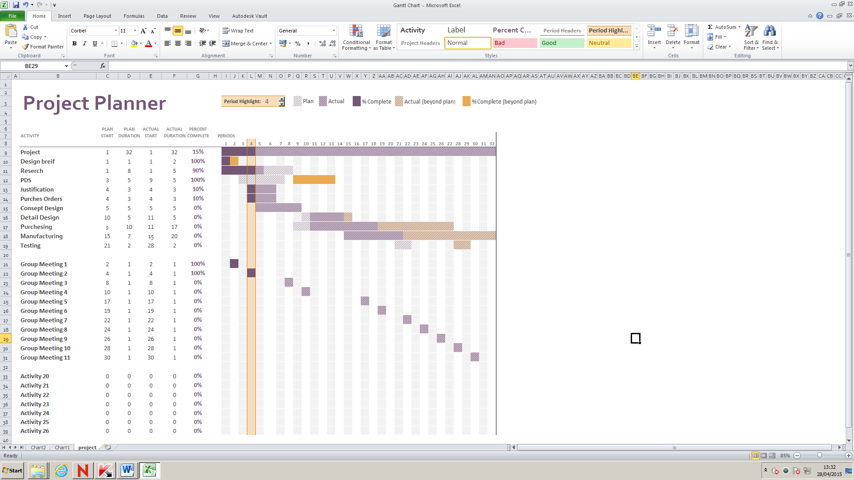
Week 4
All aspects of the project were on time at this point. The design brief had been started and research was underway.
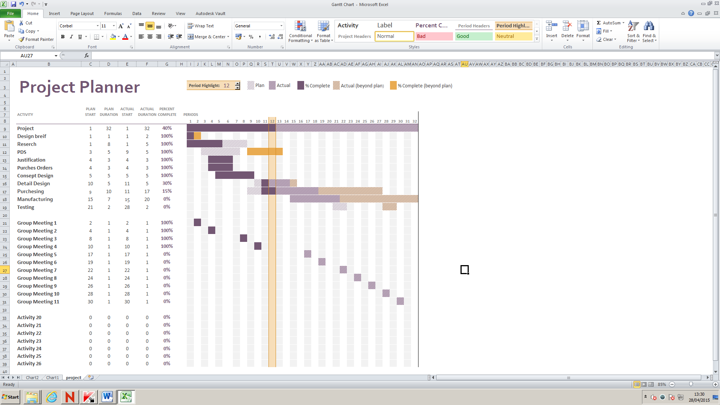
Week 12
By week 12 the PDS had been completed and achoise of suspension had been selected. The group had various meeting and purchesing of material had commenced.
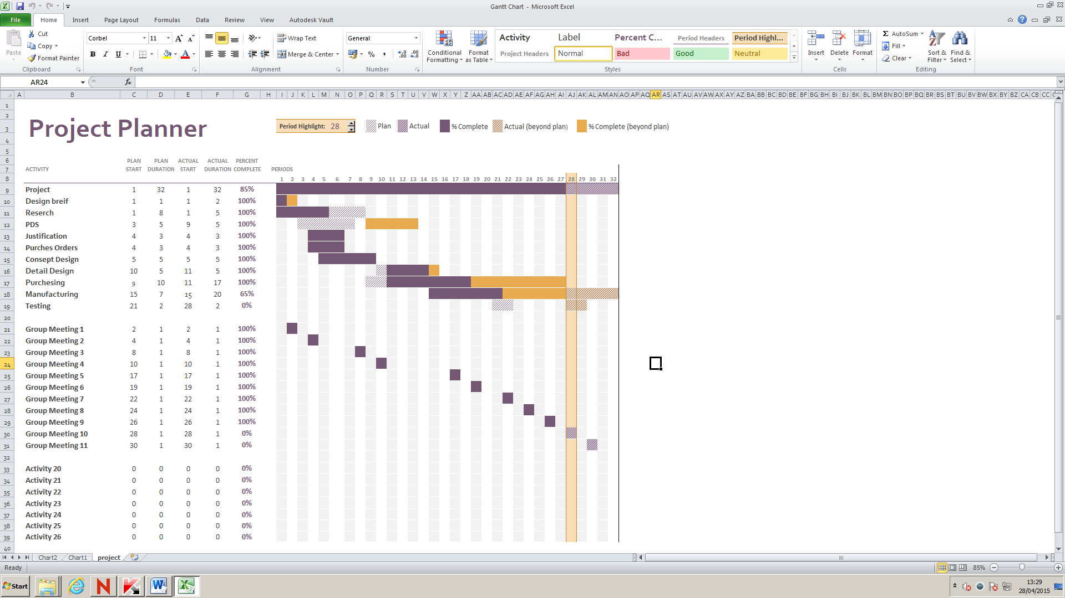
Week 28
Towards the end of the project it is apparent that time management could have been taken more seriously. Some aspects of the project had slipped but have been caught up on. Manufacturing is behind but will be caught up by the end of the month. Initial testing cannot proceed till the manufacturing has been completed.
Research material and activities
In order to fill the decision matrix I had to first evaluate and research all areas of the suspension. My initial research was based around Double Wishbone, Trailing Arms, Single Wishbone and Solid Axles. Once I had enough information on each aspect I used the information to fill in my decision matrix.
After I had completed my research and decision making for the wishbone I moved to selection of materials. The materials that I looked at were aluminium or steel. Once again I used a decision matrix in order to make a final decision.
 | Weight | Availability | Machinability | Time | Cost | Total
Aluminium | 2 | 1 | 2 | 1 | 1 | 7
Steel | 1 | 2 | 2 | 1 | 2 | 8

Due to higher availability, lower cost and easy manufacturability the steel has scored higher than the aluminium. This means that steel will be used for our project. After speaking to ABT we found we could have 19mm tube for free once we know the quantity that we will need.
The final research that we did was in to purchasing. The research was based around how much items would cost and were the best places were to get them. Most of the purchasing could be done locally and with local stores willing to lower prices to show support.
Log books
Logs have been kept throughout the project and can be found at the back of this document. The logs show issues that we came across as well as what was done from week to week. In my logs I have discussed in detail what I have done week to week from research and design through to manufacturing. The logs can be found at the back of this document.
Findings
Initial ideas
My initial ideas and designs were originally based around using trailing arm system that would be mounted at the back of the Kart. Once I had completed research in to different types and completed my wishbone matrix I was able to see that I should solely focus on the single wishbone suspension. Once I decided that I would focus on single wishbone suspension I came up with ideas for hubs. I also looked in to shocks and how I would mount them.
Reason for selection of the final idea
My finial idea was based mostly on ease of manufacturing but also had a certain amount of aesthetics involved. The final idea would be an A shaped wishbone that would be attached to the chassis via two rose joints. The rose joints would fit in to tabs that would be welded directly to the chassis. The rose joints would allow for movement up and down as well as a small amount of sideways movement. The Shock would be mounted directly to tabs that come off the chassis and would then mount to a plate on the top of the wishbone. The plate on top of the wishbone will have multiple holes cut parallel to the wishbone. This will allow me to have adjustability on the shock. The hub will be mad from sheet steel and will have two vertical plates attached to it that will have horizontal holes cut through them. This will allow the hub to connect to the wishbone and to a supporting arm. The hub will then be attached via rose joints. This will allow for vertical movement but will restrict the horizontal movement. The hub will have a 14mm hole cut in the centre of it to allow the wheel to be attached. The breaking system will attach to the side of the hub.

Specification of final idea
In order to make my final designs easier to visualise I have created orthographic view of the hub and wishbone. The orthographic designs will detail the dimensions of the components and were used in the workshop in order to manufacture the final parts.

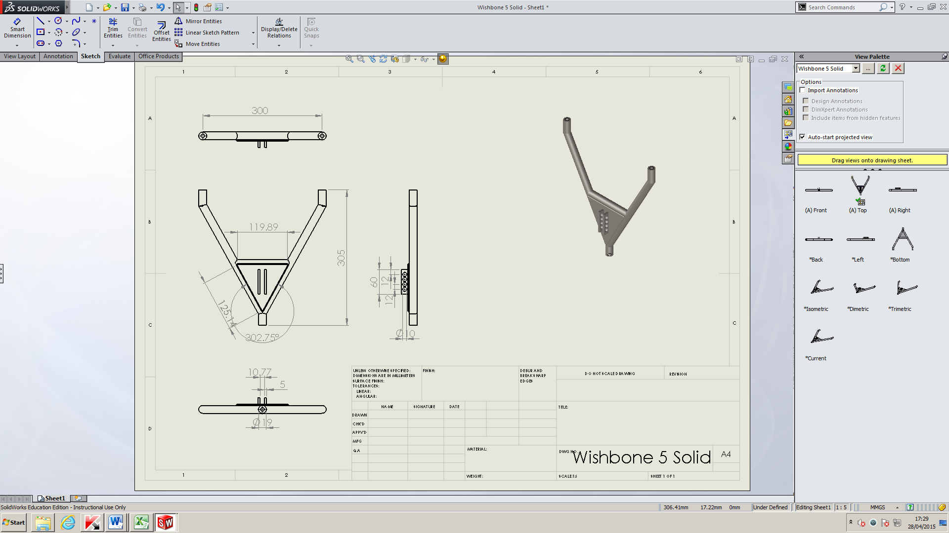
Wishbone 5 orthographic view.
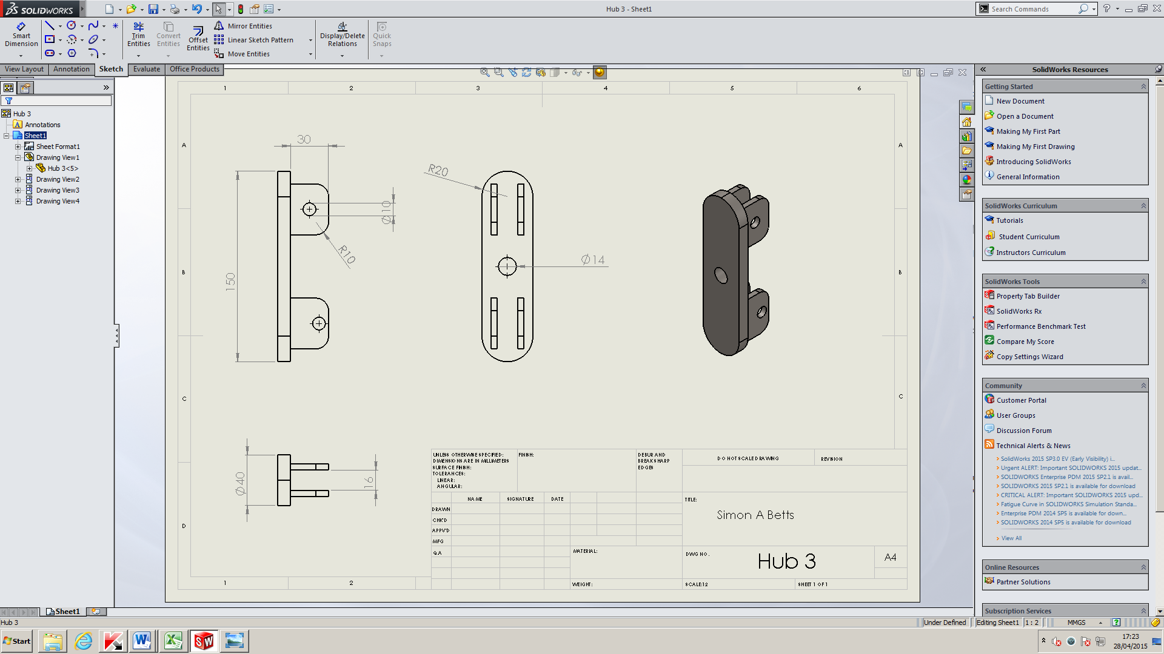
Hub 3 Orthographic View

Design / manufacturing technique to include costs
In order to keep to the Richards’s Castle rules and regulation we designed the entire chassis to be shorter and thinner than the race maximums.
The first design and basic views were designed by hand and incurred no cost to the team. Once initial designs had been created designs were made on Solidworks. Again the design incurred no cost. Once we were ready to manufacture we had to buy materials. Due to support from local company ABT we were able to get all our metal for free. Shocks cost £12 each to buy from a supplier and rose joints were purchased from Engineers Mate. 24 Rose joints cost £90. Tabs cost an extra £25. Wheels, tyres and inner tubes cost £34 each with breaks costing £15.
Manufacturing of all components has been done in the Hereford Campus engineering workshop with all welding done a Holme Lacy Campus. All members of the team have contributed to the welding and manufacturing of all components in order to get the final project completed and race worthy.
Problems and how they were overcome
Unfortunately there have been many issues and problems arise during the designing and manufacturing of the Kart. These problems were:
- Issues from start of lessons
The lesson started with no ability to accesses the computers. The class was told that this issue would be rectified shortly.
- Email address provided by Tim Morris at ABT was incorrect. New email address was acquired from Andrew Young (Tutor at Herefordshire and Ludlow College). – Tim@abtproducts.com
- Halfords did not have brakes that were ordered. After many phone calls they were unwilling to help.
- Issue: Daniel Duggan has left the course. No work has been submitted or information passed to group.
- Matthew Cattral Left the Level 3 Engineering Course. Matt submitted designs to tutor as well as a copy to myself so that we could put together a final assembly.
- Issue: Rear Suspension/ Seat.
Seat wider than the allotted room for the suspension. Resolution include: Customising a seat, cut out of an existing seat or producing a solid rear axle.
- Bending Bar
- Thomas Buckley Left The course.
In order to resolve the first issue the class tutor had to contact the IT department. Once the internal issue was fixed we were able to use the computers.
When I discovered that there was an issue with the email address that I had been given by Tim Morris I spoke to my tutor Andrew young. Andrew had worked with Tim previously and still had his correct email address.
The third issue that we discovered was that brakes we had ordered had become out of stock but Halfords system had not been updated. Unfortunately the only resolve for this issue was to use a different supplier.
Unfortunately the fourth and fifth issues we had were people leaving the college course. Only one of the students who had left had been able to contribute to the group, giving detailed designs of breaking systems. Due to Daniel being the second in charge we had to take a group vote to find out who would fill his position. Jordan was elected as the second in charge. This was a great help as Jordan is a hard working individual that had great ideas about chassis design. Daniel was also in charge of chassis design and had the experience to draw a monocoque chassis unfortunately we had to change to a space frame design due to a lack of experience through the rest of the group.
The nest issue arose when 3D assemblies were made. It had come to light that the seat and the rear suspension would interact with each other and could potentially damage both areas. A redesign of the seat was done and this resolved the issue.
Issues arose with bending of the bar. The college does not have the facilities to bent 19mm mild carbon steel. This issue was resolved by filling the tube with sand and then bending it.
Thomas Buckley left the course and unfortunately took all designs and information relating to wheels with him. Thankful there was good communication throughout the group and the wheels and tyres had already been selected and ordered. The team has only five members left.
Testing
In order to test whether or not the wishbones would be up to scratch before they had been manufactured I used SimulationXpress feature on the Solidworks program in order to see how the designs would react to the forces that were expected to be applied to the wishbone. The following pages show the results of the simulation.
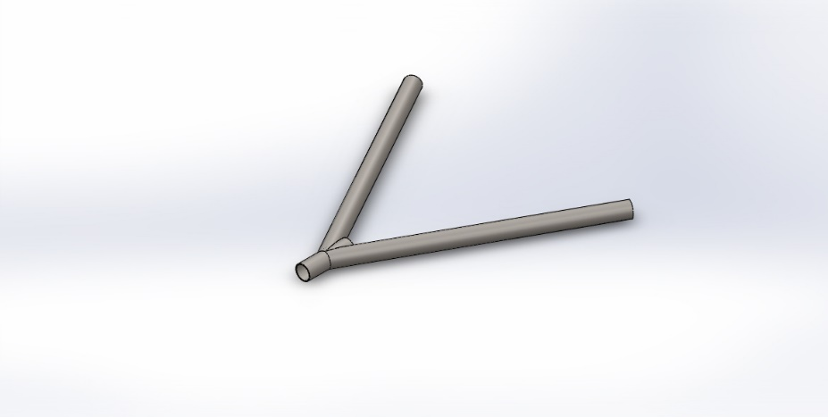 | Simulation of Wishbone 5 Solid  Date: 15 April 2015  Designer: Simon A Betts  Study name: SimulationXpress Study  Analysis type: Static  Table of Contents  Model Information 15  Material Properties 16  Loads and Fixtures 16  Mesh Information 17  Study Results 18  Conclusion 20

Model Information

Model name: Wishbone 5 Solid
Current Configuration: Default
Solid Bodies
Document Name and Reference | Treated As | Volumetric Properties | Document Path/Date Modified
Cut-Extrude3 | Solid Body | Mass:0.282953 kg  Volume:3.59534e-005 m^3  Density:7870 kg/m^3  Weight:2.77294 N | F:\Project\Susspension\Wishbone 5 Solid.SLDPRT  Apr 15 16:43:02 2015

Material Properties
Model Reference | Properties | Components
 | Name: AISI 1020 Steel, Cold Rolled  Model type: Linear Elastic Isotropic  Default failure criterion: Unknown  Yield strength: 3.5e+008 N/m^2  Tensile strength: 4.2e+008 N/m^2 | SolidBody 1(Cut-Extrude3)(Wishbone 5 Solid)

Loads and Fixtures
Fixture name | Fixture Image | Fixture Details
Fixed-1 |  | Entities: 2 face(s)  Type: Fixed Geometry

Load name | Load Image | Load Details
Force-1 |  | Entities: 1 face(s)  Type: Apply normal force  Value: 1200 N

Mesh Information
Mesh type | Solid Mesh
Mesher Used: | Standard mesh
Automatic Transition: | Off
Include Mesh Auto Loops: | Off
Jacobian points | 4 Points
Element Size | 5.34791 mm
Tolerance | 0.267395 mm
Mesh Quality | High

Mesh Information - Details
Total Nodes | 15504
Total Elements | 7729
Maximum Aspect Ratio | 23.606
% of elements with Aspect Ratio < 3 | 8.94
% of elements with Aspect Ratio > 10 | 0.802
% of distorted elements(Jacobian) | 0
Time to complete mesh(hh;mm;ss): | 00:00:03
Computer name: | SIMONLAPTOP

Study Results

Name | Type | Min | Max
Stress | VON: von Mises Stress | 740340 N/m^2  Node: 2327 | 5.72238e+008 N/m^2  Node: 2180
Wishbone 5 Solid-SimulationXpress Study-Stress-Stress

Name | Type | Min | Max
Displacement | URES: Resultant Displacement | 0 mm  Node: 1 | 9.37546 mm  Node: 2000
Wishbone 5 Solid-SimulationXpress Study-Displacement-Displacement

Name | Type
Deformation | Deformed Shape
Wishbone 5 Solid-SimulationXpress Study-Displacement-Deformation

Name | Type | Min | Max
Factor of Safety | Max von Mises Stress | 0.611634  Node: 2180 | 472.756  Node: 2327
Wishbone 5 Solid-SimulationXpress Study-Factor of Safety-Factor of Safety

Conclusion
Wishbone preforms as expected.

Conclusions
- Evaluation of the project
The conclusions
My conclusion is that the project as a whole was a complete success. We have built a working soapbox cart before the race at Richards Castle on the Sunday 12th July 2015.
Recommendations
- Further work needed
- Modifications or refinements
Recommendations
It is my recommendation that if this project is to be done again in future it should be done with a stable source of funding or support funding from sponsorship in order to reduce cost to the individual team members. It is also my recommendation to have more set time in the workshop in order to keep forward momentum going on the manufacturing of components.

Appendices
Log book
Introduction
The bellow log is a detailed account of what I have done over the last academic year. The log shows issues that have occurred and what I have done each week.
Week 1 2/09/2014
Today was the first project class of the year, we had a small discussion with our tutor on what would be expected in this lesson, from my understanding we will be undergoing a project of our (the Groups) choice and completing various activities like a report and undergoing the project we are discussing.
After some discussion as a group there was no clear cut decision on what we would be doing for our project.

Week 2 09/09/2014
Today the class seemed more willing to cooperate with the project lesson, we quickly organised ourselves around a table and started discussing what we would like to do as a project. Some project ideas where:
- Soap box car
- Floating water bike
- “Robot wars” style robot
- Peddle Car
- Rube Goldberg machine
After carefully analysing all the option in conjunction with college health and safety we decided we would break in to two groups one focusing on a floating water bike and the other being a downhill soap box car.
The two teams consisted of 8 people, in the car team where Simon Betts, Daniel Duggan, Jordan Powell, Tom Buckley, Jake Pontiflex, Tom Duggan, Tom Fellows and Matthew Cattral. The second group named the boat group contained the rest of the Engineering Level 3 2nd years.
The car Team under the leadership of Simon A Betts where able to speedily and efficiently get started with planning of their time and ability’s.
The management system was as follows
Simon Betts – Team Leader
Daniel Duggan – Second in charge
Tom Buckley - Sectary
Jordan Powell – Team Member
Jake Pontiflex – Team Member
Tom Duggan – Team Member
Tom Fellows – Team Member
Matthew Cattral – Team Member
After discussion we decided we would build a soap box downhill racer that would be raced at the Richards Castel Soapbox Derby next year (2015).
As a group we decided that working on 4 subsections would make the project easier to complete, therefor Simon Betts and Tom Fellows would work on the suspension, Daniel Duggan and Jordan Powell would work on the chaise, Matthew Cattral and Tom Buckley would work on the Wheels and Jake Pontiflex and Tom Duggan will work on the breaking system.
Once we had all agreed our position we decided to carry on with a plan. As of week 2 we would complete 3 designs each of our subsection and finish all designs by Christmas. To ensure we are able to keep up with this target we continued with research on our subsections along with rules of the competition.
Matters Also Discussed:
- Rough Body Shape
- How will we finance the project
- Where could we get extra Finances
- What is the Maximum Size of our vehicle
- What will the track be like
- What are the times and speeds of the vehicles that have been down the rout.

Week 3 18/09/2014
Today the team started the lesson with refining of research that we collected over the last week, after approximately 30 minutes the group sat around the main centre table and had a groups meeting.
In the group meeting Daniel Duggan took minuets, our first point of action was to move as a group to the workshop to check out the 2012 cart and evaluate the pros and cons that we could see with the vehicle. During our time in the workshop we briefly discussed areas we liked, disliked and also took photos, once this was completed we returned to the group meeting in room T204.
In the meeting we talked in depth about the 2012 cart and how we would build our cart using the research we had collected, the decisions that where agreed upon where:
- Steering to be “rack and pin”
- Use of 20inch BMX wheels with 14mm centre to attach to a 14mm stub axel that will mount to the cassis.
- Suspension at the back of the cart will be trailer arm with a spring.
- The Frame will be a monocoque design.
Once the decisions where mad all members of the team dispersed to start design drawings and sketches, during this time I took it upon myself to make a list of all the different ideas the group had put forward for each section with approximate cost, after highlighting the items we will be needing I put together a sheet showing the costs of the project.
Week 4 23/09/2014
In the lesson on the 23rd of September the lesson started with a full class chat with our course tutor Anthony king about Gantt charts; we discussed how they should be used in our projects.
Shortly after the class discussion myself Daniel Duggan, Jordan Powell and Tom Fellows decided to look at the previous year’s cart again to evaluate a few detail in more depth e.g. dimensions of the whole cart, size of the suspension, length of the wishbone ext.
I completed two free-hand sketches of various parts in my area, one was of a wheel hub and the other was of a trail-arm suspension.
Once I completed the sketch I decided to look in to trail arms on the internet once again to compare my drawing to other trail arms found on bikes, mini coopers and other carts.
Later in the lesson Tom Fellows and I decided to get together and have a chat about the suspension, axel and hub, we decided it was best for tome to take over control of the front and I would work on all aspects of the back.
Close to the end of the lesson I decided to do some research in to sponsorship, after looking I was able to see that we should try not to go out of a 10 mile radius of Hereford and try to concentrate on metal works, bike shops and other outdoor activity stores, my first target is to call at least 10 stores before the next lesson on Tuesday the 30th of September.
To wrap up the lesson we had a class talk instigated by myself about what budget we will get from the college, after listening to Anthony King we found out we will not be presented with a budget but instead we would have to work for it, our group as a whole will need to put together a presentation to Anthony King, Robert Kershaw and Steve Dixson, in our presentation we will need to ask for funding, give a breakdown of costs, where they will be spent and reasons why we deserve the money. In the meeting we stated that students from both teams will pay for the frame steel as a gesture of good will and to increase chances of getting funding from other sources.
Before my group left for the day I asked them all to evaluate and determine costs for each of their individual subsections in the group, I am hoping that they will deliver by the 30/09/2014 so that I am able to start planning a presentation to shows our course tutors to try and achieve funding for our project.
I have set myself some homework to this is as follows:
- Research safety on the vehicle
- Call 10 companies around Hereford to try and achieve sponsorship for our cart.
- Evaluate cost of rear suspension.
These are all to be done by the 30/09/2014

Week 5 30th September 2014
In the lesson on the 30th of September 2014 we started the lesson with a class chat discussing information that would need to be submitted to pass the project class with full distinction. Information such as a full up-to-date diary will be needed.
After the group chat I started to right a document stating my choice for the suspension and justifications on why I thought it was best. This document will be submitted with my final project.
During the lesson it was confirmed that Jake P and Tom D would take charge of seatbelt choice and justification.
During the lesson I contacts Tim Morris at ABT Ross on Wye to enquire if they would be willing to sponsor use or help use in relation to materials for the cart. During the convocation with Tim he stated that they would be able to help and requested that we sent him the full designs once they were completed. I confirmed everything that we spoke about in an email. A full manuscript of the convocation between myself and ABT can be found in my project book.
Once I completed my convocation with ABT I called the scrap dealer at Monmouth (Mr Blake’s) to enquire if they had any suspension springs that we could buy cheap. They did not.
Matthew Cattral reserved V breaks at Halfords Cardiff for £1:00 each that I would pick up on Thursday 2nd October 2014.
Towards the end of the lesson I called together a group chat to discuss costs as of 30th September 2015. The information put together stated the following:
Materials (Metal): £80
Steering: £100-£200
Harness: Sourced by Jordan
V Breaks: £3
Disk Beaks: £50
Shocks: £60
Rose Joints: £3-£4 Each
Total: £500
Agreed with the rest of the group that we will need to work harder to reduce costs. Recheck Prices on week 7.
Agreed that the colour scheme we would use will be Blue and White.
Week 6 7th September 2014
Issues from start of lessons
The lesson started with no ability to accesses the computers. The class was told that this issue would be rectified shortly.
Email address provided by Tim Morris at ABT was incorrect. New email address was acquired from Andrew Young (Tutor at Herefordshire and Ludlow College). – Tim@abtproducts.com
Halfords did not have breaks that were ordered. After many phone calls they were unwilling to help.
For an hour of the lesson we had a guest speaker (Jenny Marsh) in to speak to the class about UCAS and university option for all the students.
Once the Speaker had left I continued to draw sketches of the suspension. These Sketches can be found in my project book.
To do: Gantt charts need to be created.
Week 7 14th October 2015
Email received from Tim at ABT on the 9th October 2014 confirming our convocation on the 30th September 2014.
Gantt chart created. Can be found in my Project Book.
Sketches of rear Hub and Wishbone completed for Double Wishbone Suspension. Observed that there may be difficulty constructing double wishbone suspension.
Week 8 21st October 2014
Started the lesson with a Group meeting. Minutes from the meetings will be kept by Thomas Buckley. All minuets can be found in Project Book.
Chat 1 week late. Talked about costings.
Chassis £65-£70
Suspension £20
Wheels £40-£50
2x V Breaks £15 Each
Steering £100
Once we concluded that we needed to work harder to drop the price of the whole project I went to the workshop with Jordan. Whilst we were at the workshops we checked to see what materials there were and see if any of it would be useful to use in an effort to drop costs.
George Tasker from the other group offered to contact his supplier to increase their order for rose joints to ultimately reduce the costs. I told George that we would be needing 28 Rose Joints.
Worked out with Jordan that the entire length of my wishbone is to be 305mm.
Started to draw wishbones on Solidworks.
Week 9 28th October 2014
Checks done by myself to see what I need to complete. Checks include; Project Brief, PDS, Concept Design, Detail Design, Manufacture/ Test and Potential Sales.
Group Meeting: Tom Duggan told the rest of the group that he had access to a workshop we could use if necessary.
Daniel Duggan commented that he was not happy on the course and may be leaving. Contingency is for Jordan to take over as second in charge of project.
Matthew Cattral informed the group that disk brakes would cost £70 for 2 sets.
Discussed potential of attending a welding course as the Engineering Level 3 Year 2 groups did the year before use. Enquired with Anthony King and was told he would sort it out.
Minuets from meetings can be found in the project book.
Solidworks: Once the group meeting was completed I continued to finish my first double wishbone suspension unit. Once all parts were completed I created my first assembly. Pictures can be found in Project Book.
Week 10 4th November 2014
Issue: Daniel Duggan has left the course. No work has been submitted or information passed to group.
Group Meeting: Jordan Voted to position of Second in charge of project.
Tony informed the class that there was wire located on the shelf to allow use to build prototypes.
Group went to workshop to view older project and take photos. Photos can be found in project book.
Took measurements from tallest member of the team to ensure that all members of the team can fit in the cart. Tomes measurements were: 1100mm from floor to helmet when sat down. Clearance of 60mm. from this we could calculate that the base bar to second bar should be 400mm.
Between week 10 and 11 13th November 2014
I called various Go Karting sites to see if we could have a race day. I believe the race day would allow use to get a better idea of who should be the driver of the cart.
Gloucester – JDR
Driver Experience; £15 for 15 minutes, £20 for 25 minutes, £25 for 35 minutes, £30 for 40 minutes or £35 for 60 minutes for driving.
There are also races held by JDR. Grandpre is £35 for 10 practice laps followed by 20 race laps with the top 12 drivers undergoing a further 10 laps. The top 3 will also receive trophies. They also offer a Supapre which is £40 this consists of 10 practice laps followed by 20 race laps with the top 12 drivers undergoing a further 20 laps. Again the top three drivers will get to trophies.
Newport – SupaKart
SupaKart are open on Mondays between 12:00pm and 14:00pm but would open earlier for the college. There representative has sent me an email with a full price list. As well they offer two free entries if we were to take 18 people.
This email can be found in my project book.
As well as contacting various Go Karting tracks I took the liberty of calling Ian Boomer at Richards Castle (Technical Advisor) on 07885067342. Mr Boomer advised me that it was a good sign that we are prepared and ready at such an early stage. Mr Boomer suggested looking in to sponsorships from Red bull as well as David Peace at Peace Cycles Ludlow. During our conversation Ian told me that the record was set by a cart called the C12 (38 Seconds) which was design and manufactured at a composites company. Ian also commented on checking up on insurance due to speeds reaching approximately 40mph as well as an incident where a tutor from Ludlow College was taken to hospital. Ian also informed me that in the past people have had issues with bike tyres buckling easily. Breaks are also a must on the cart or we will fail the safety inspection. The invigilators would also like to see wrist restraints on the steering wheel as there are often issues with peoples flailing limbs. Recommendations also included making sure our cart had plenty of camber and caster, as well as looking on UKGSA forums for parts. When the cart is almost finished Ian Boomer would like to see it.
After my conversation with Ian Boomer I called Dave Peace and Peace Cycles Ludlow. Dave informed me that we would be able to test drive at Richards Castle as a favour to the college. The main points that were highlighted by Dave was to have plenty of negative camber. Net/ restraints included to stop putting arms out during a crash. Dave would look in to giving use wheels at Trade Price as well as hubs.
Red bulls contact details are: 02031172000 as well I have sent an email to Red bull through their website.
Week 11 18th November 2014
Meeting discussing progress so far.
Watched Guy Martins Speed, where Guy designed and raced a downhill soapbox cart to break the Guinness World Record, I believe this helped understand some of the key principles that we would need to know like overcoming inertia.
Once we finished watching Guy Martins Speed we continued with designs on Solidworks.
Week 12 25th November 2014
Spend the whole lesson continuing with sketches for my CAD Assignment.
Week 13 2nd December 2014
Group Chat about Progress as well as discussing everyone getting invoices so that we can put forward Purchas orders to Steve Dixon before Christmas.
So far we will be collecting rose joints for a company by the name of Engineers Mate contact number 01384402410. Sheet steel and Round pipe will be collected from ABT for a total Cost of £12. Rack and Pinion is still being sourced but is likely to be acquired from EBay. Springs for Suspension are being bought through Petrol Scooter. Breaks have been suggested at £39.99. An email was send to Peace Cycles at shop@peaceyc.co.uk this email was requesting invoices.
Dimensions of materials we will be needing from ABT are; Sheet steel- 1 piece 2600 x 500mm, 20mm tube 15m and 30mm tube 8.5m
Week 14 9th December 2014
Myself Thomas Fellows, Oliver Houghton and Tom Duggan visited local scrapyard in Leominster during our lunch break to find potential parts. When we returned we were late for our traditional lesson time and continued with our designs. We were also marked as Late with reason.
Week 15 16th December 2014
Purchase orders created and submitted to college.
Had a quite lesson mostly discussing university applications before breaking up for Christmas.
Christmas Break
Matthew Cattral Left the Level 3 Engineering Course. Matt submitted designs to tutor as well as a copy to myself so that we could put together a final assembly.
Collected steel from ABT, Measured Steel and found it was all too desired lengths.
Week 16 06th January 2015
Stated lesson talking as a class with our tutor about Process Sheets.
Designed process sheets for costing. Our services are to be charged at £40 per Hour.
Jordan and I unloaded metal from my car.
Talked as a Class with tutor about how the final project should be laid out and submitted.
Took the group with me to the workshop were we measured out all of the metal and found what pieces needed additional cuts. As a group we chalked lies on the workshop floor and laid out how the cart will look. See photos in project book. First visualisation of how the end cart will look and feel.
Issue: Bending Tube.
We have no means of bending the tube at the college. I went to different departments where we tested various methods including heating and bending and a 3 tonne press to try and bend the tube but found it collapsed. Anthony King said he would contact Holme Lacy campus to enquire if they had anything we could use.
Week 17 13th January 2015
Finishing designs ready for final assembly.
Money collected for rack and pinion.
Simon £10, Matt £5, Tom F £10, Jordan £10, Tom D £10, Jake £10 Totalling £55.00
Overtime: Friday 16th January 2015
Jordan and I came to college at 08:30pm to cut bar to length so that Jordan and weld them at home over the weekend. There are welding facilities at the college but unfortunately there are no welding curtains so welding must be done by students with facilities or at Holme lacy campus when it can be arranged.
Week 18 20th January 2015
Issue: Rear Suspension/ Seat.
Seat wider than the allotted room for the suspension. Resolution include: Customising a seat, cut out of an existing seat or producing a solid rear axle.
Produced Jpegs of all my Solidworks creations.
Worked on Gantt chart
Put a Deposit down for 20” BMX wheels at Coomb cycles Hereford. Wheels £25 each. Quoted inner tubes for £3 each and Tyres for £7 each.
Group had a quick discussion on aesthetics which will need to be completed next week.
Decided I would reduce Jordan’s work load and take the seat design and manufacturing on myself.
Overtime: Monday 26th January 2015
Wheels collected from Coomb Cycles Hereford. Total paid £100
Money collected from group to pay for wheels and rack and pinion.
Rack and Pinion total cost £90
Week 19 27th January 2015
Started the lesson by taking my group (minus Jordan) through the slides that form our group presentation. Discussed who would say what parts ad at what time. After agreeing on changes that need to be made we separated to do our own work. Once I returned to my work station I printed all my various Gantt charts from week one to nineteen ready to take to my university interview.
After printing Gantt charts I continued to print all relevant documents that have been completed in order to start assembling my final project report.
To ensure that I do not miss anything I asked my course tutor (Anthony King) for his advice and asked how he would like to see the final project report presented and in what order.
During the lesson I emailed Tim at ABT to ensure that they had been paid. Tim got back to me saying that he forgot to send an invoice and that he would write it off for use.
The last hour of the lesson was taken up by a discussion about the second CAD assignment.
Week 20 03rd February 2015
For the beginning part of this lesson I assembled together a first draft of my final project. This was for two reasons, the first is to take to a university interview. The second reason was to give me the opportunity to see what section are missing and what sections would need bulking up.
Once I had completed assembling my first draft I called together a quick group meeting. We discussed where we currently were with each of a sections and decided what each of use needed to do over the next couple weeks.
Week 21 10th February 2015
In this lesson I worked out how much extra material I would need to order for the construction of the 4 lower wishbones. Tom Fellows worked out how much would material would be needed for the two top wish bones. I then contacted Tim Morris at ABT and placed an order for the material. I then moved on to researching how many rose joints we would need for our project, I then began to research how much they would cost and where I could order them. I finished the lesson by collecting all CAD files from the group and assembling them together.
Week 22 24th February 2015
I spent this lesson in the workshop cutting materials to length with Jordan Powell. I collected £7.50 from everybody in our group in order to purchase tabs to mount to the chassis. This would save time and effort of manufacturing them.

Overtime: Friday 27th February 2015
Friday morning I collected the wishbone material from ABT in Ross on Wye before heading to Holme Lacy Campus. At Holme Lacy Campus myself Tom Fellows and Jordan Powell spent the morning learning to weld using a MIG welder. Once we had a basic understanding of welding we continued to weld in our respective areas. Tom Fellows and I cut some of the material that needed cutting and started to produce jigs for holding our material in place while we tack them together, this will reduce deformation due to the heat of the weld. Jordan continued to weld the chassis. Jordan had previously welded the majority of the chassis at home.
Week 23 03rd March 2015
The beginning of this lessons started with final preparation of our group project. As soon as we had finished our preparation we presented our project with a power point presentation to the rest of our class and tutor. The next part of the lesson I looked at rose joints again to see if I could find any cheaper than seven pounds. Close to the end of the lesson we sat down as a group with Tony King (Course Tutor) in order to discuss what purchase were left. The purchase were are follows:
- 2x Inner Tubes
- 4x Tyres
- 28x Rose Joints
- 2x Hydraulic Breaks (Tony volunteered to buy these closer to the race date)
A rough estimation of £30 pound each would cover all costs needed to finish the project. This did not take in to account powder coating or painting of the final assembly.
Overtime: Friday 6th March 2015
I spend Friday with Jordan and Jake working on the tabs that would be used on the chassis. As well as cutting materials wishbones. Jake spent his time cutting all materials needed to attach the rack and pinion system to the chassis.
Week 24 10th March 2015
The start of this lesson was spent listening to the other group’s presentation. I spent some of the lesson designing the hub that would be used on the rear of the cart. The final part of the lesson I worked in the workshop finishing my jig for welding.
Overtime: Friday 13th March 2015
I spent this time in the workshop cutting materials and ensuring they fit in the jig.
Week 25 17th March 2015
Unfortunately I was absent from this lesson.
Overtime: Friday 21st March 2015
Once again this time was spent machining materials for the wishbones and hubs.
Week 26 26th March 2015
The beginning of this lesson was spent finalising assignments and handing them in due to this being the last lesson before the end of the winter term. After collecting the final £30 pounds from all members of the group I was able to call Coombs Cycles, Hereford to reserve out tyres and inner tubes. I then called engineers mate to get a quote for 10mm rose joints. The best price that engineers mate could do was three pound each as long as we bought thirty rose joints. During the rest of the lesson Tony showed myself and the rest of the class how to use simulation express to get testing results for our components. I spent the final part of the lesson continuing the assembly of the cart on Solidworks.
End of Term
During the term break I was able to collect the tyres and inner tubes from coomb cycles. I also ordered rose joints. Over the half term I spent time working on my second draft of the final project with intention of submitting it on the 28th April 2015.
Week 27 14th April 2015
The beginning of this lesson was spent working on assignments. Once I completed assignment work I called Thomas Halford at Engineers Mate due to the rose joints not turning up over the Term Break. During the lesson I realised that we had not bought bolts to attach rose joints to the wishbones and the chassis. I have looked in to purchasing and they will cost approximately ten pound from screw fix.
Overtime: Friday 17th April 2015
Friday was spent in Holme Lacy finishing welds. At Holme Lacy I realised that one set of wishbones had not been cut. I proceeded to cut them and start welding them.
Week 28 21st April 2015
I spent this lesson working on assignments. For a brief time the head of engineering at Hereford campus discussed with the class caster and camber. Although we had already done the research of caster and camber the instruction and description were very helpful.
All drawings and designs
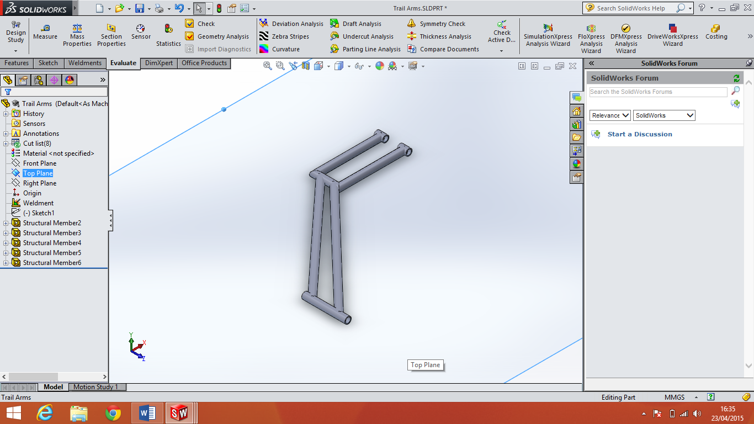
The above design is my first initial design of a trailing arm system.
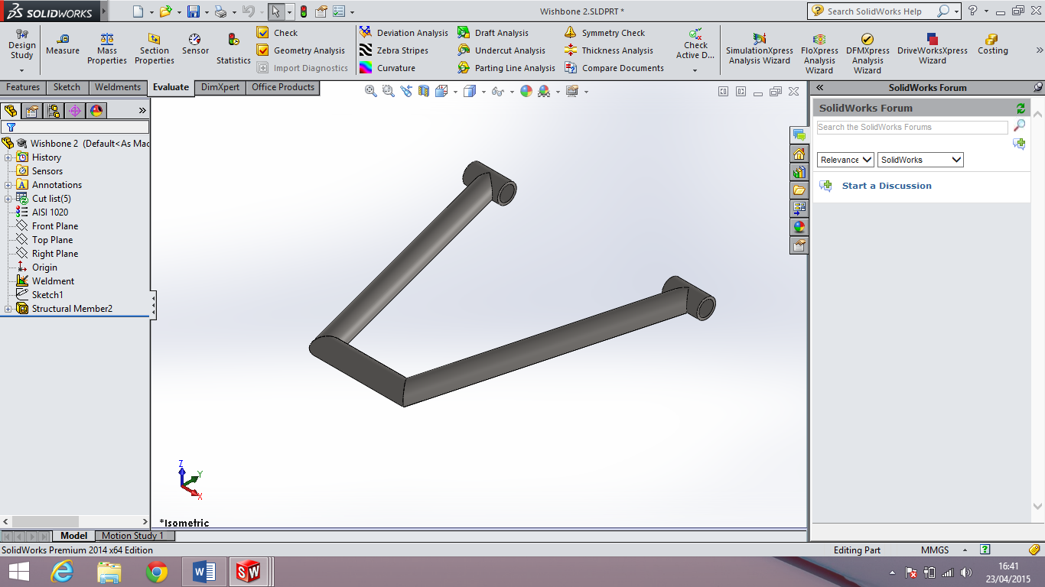
Wishbone 2
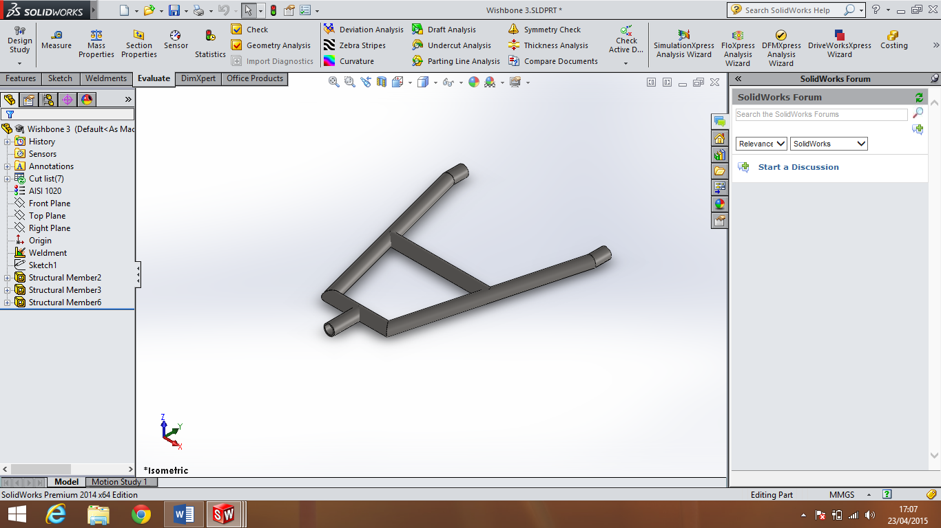
Wishbone 3
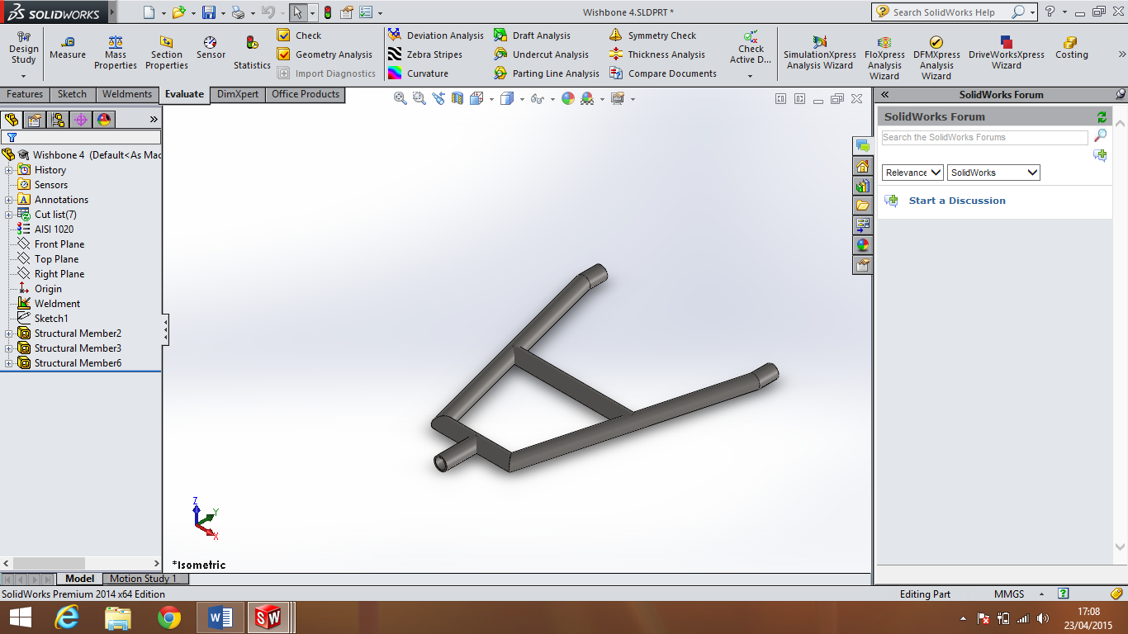
Wishbone 4
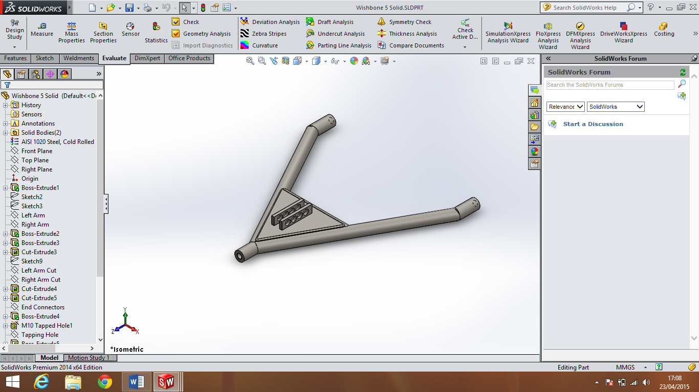
Wishbone 5
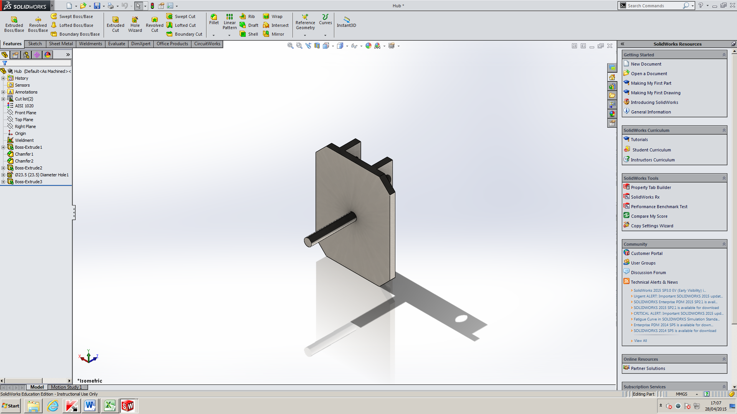
Hub 1
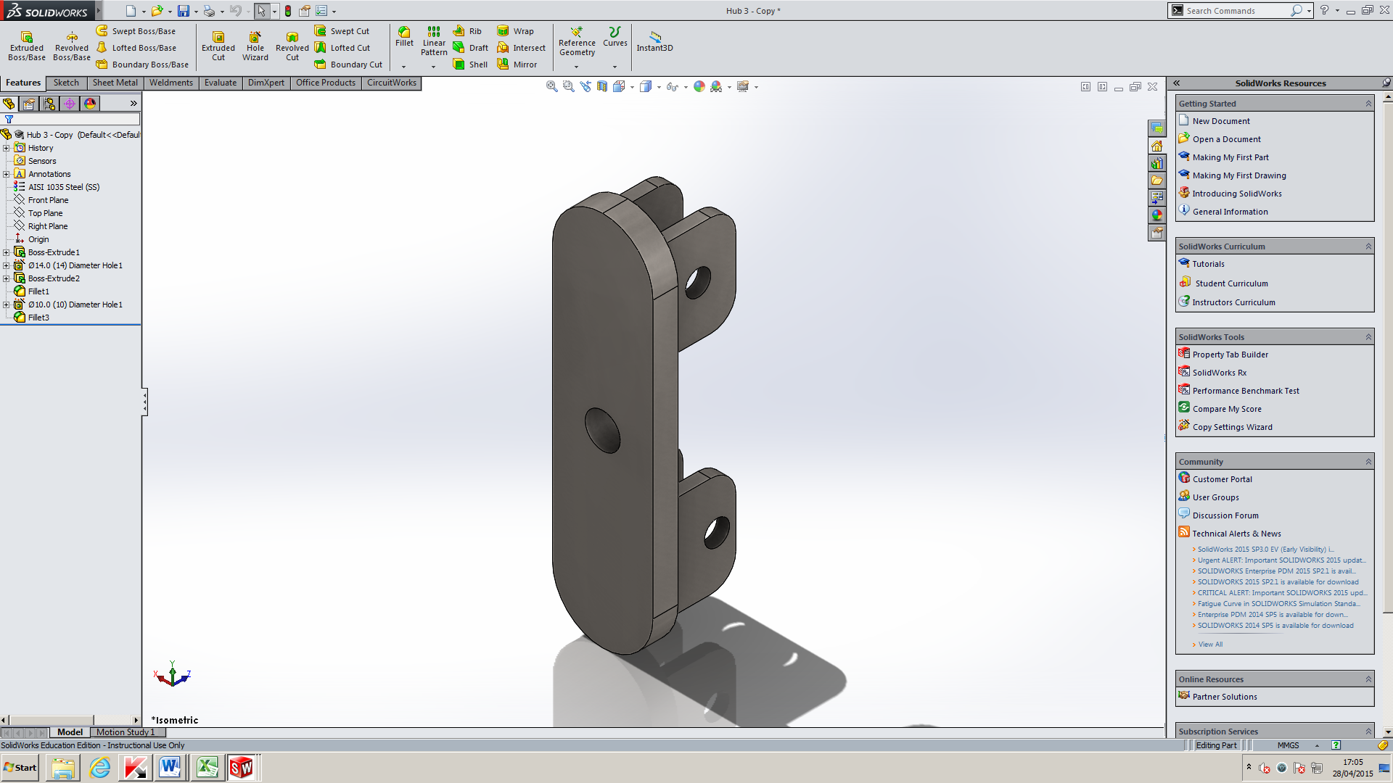
Hub 3
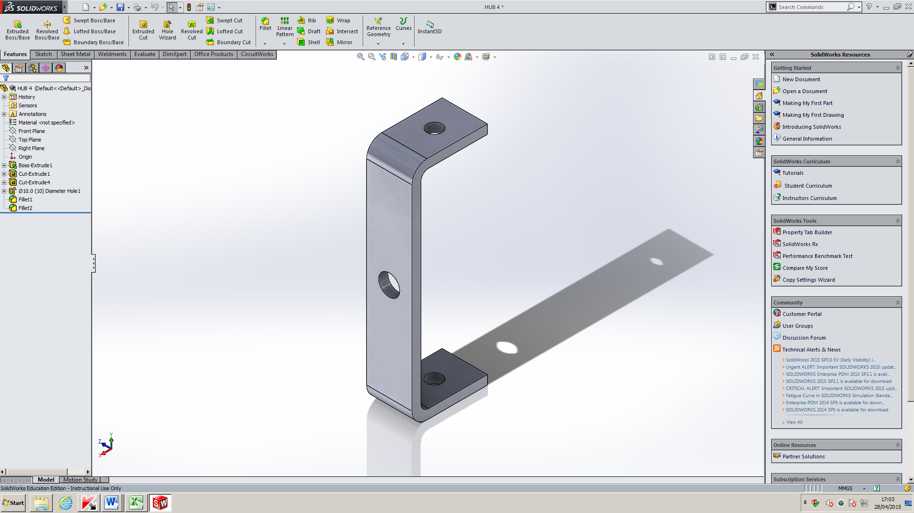
Hub 4
Product Design Specification
Product Design Specification
Soap Box Kart
Simon A Betts
This PDS will outline the Specifications for building a Soap Box Kart based on the design brief created by Mr Simon A Betts. The PDS will outline all the details aspects that will have to be incorporated in to the design of the Soap Box Kart to enable the cart to be raced at Richards Castle Down-Hill Soap Box Darby.
The following product design specification will cover the following points:
- Performance
- Environment
- Life in Service
- Maintenance
- Target Product Cost
- Competition
- Packing Company Constraints
- Market Constraints
- Patents
- Political and Social implications
- Shipping and Transport
- Quantity
- Manufacturing Facility
- Size
- Weight
- Aesthetics
- Materials
- Product Life Span
- Standards and Specifications

Performance:
The Cart must reach the bottom of Richards Castle track from the top starting position.
Environment:
The system will be operating outdoors and will experience varying temperatures.
Life in Service:
This product should be designed to last as long as possible, minimum of five runs.
Maintenance:
The components will all have to be easily accessible and easy to maintain.
Target Product Cost:
Costs should be kept to a minimum due to mostly being funded by student. The cost

Competition:
The main competition will be Herefordshire and Ludlow College’s Second team lead by Toby Wynne-Owen.

Packing Company Constraints:
As this is a one off build there will be no packing requirements.

Market Constraints:
N/A

Patents:
N/A

Political and Social implications:
N/A
Shipping and Transport:
The cart will be transported in a trailer or on a roof rack. The group has transport facilities.

Quantity:
There will only be one race cart made.
Manufacturing Facility:
Manufacturing will have to be done at Hereford campus or at Holme Lacy Campus on specific dates organised by the college.

Size:
Maximum length 2300mm measured from front to rear of soapbox.
Maximum width 1118mm measured from outside to outside.
Minimum eye height 700mm measured from driver’s eye line, when seated, to the road surface. Drivers to remain seated at all times.

Weight:
No Maximum Weight Specified.

Aesthetics:
Component should look modern. The aesthetics should not compromise the performance. The final colour will need to be blue and white.

Materials:
Materials must be recyclable and comply with Health and Safety at work act.

Product Life Span:
Product should be designed to last as long as possible. But must at last for ten runs of Richards Castle track and still be able to run.

Standards and Specifications:
There are no British standards that govern the race kart but it must conform to Richards Castle rules and regulations.

Resources
Customer Design Brief, Simon A Betts, 20th April 2015.
Race Rules and Regulations, 20th April 2015: http://soapbox2015.wix.com/richards-castle-soap#!enter/c66t.
Evaluation/ Conclusion
In this section I will be evaluating the project as a whole. I will discuss some of the problems that we have faced and evaluate how we have dealt with them. I will also evaluate some of the positives and negatives of the project. I will discuss what I believe went well and what I would change in the future as well as highlight areas that we did change in the current project. Finally I will write a short conclusion on how the project went as well as determine whether the project was a success or a failure.
From the beginning the project started off well. We had a full team of eight, and we were able to quickly agree on what we would like to design and build. Because of this we were able to break up in to pairs and get our research started quickly. All members of the team were very keen to get the project underway and excited about how it would turn out. During the first few months the group kept up the progress and completed the research stage and made a start on their designs. This was good for the group as it allowed more time at the end stages for manufacturing and assembly.
The motivation of the group was one of the main characteristics that I thought made our group strong. Another one of the impressive attributes of our group was the ability to hold together throughout the project in order to get it completed even though we lost a lot of our team. The team went from eight people down to four, which meant that the workloads increased on all members, even with the additional workloads the team held together. The third area that was impressive was the way that every member of the team was willing to help manufacture and give advice with every area of the project even though they had their own areas to focus on, this allowed for the team to bond with each other and gave all member of the team a level of ownership over the cart. During the project I felt that there were a few areas that I performed well at. I had to balance my college work with my part time job which I believe I have done very well. I also managed to meet deadlines on time and keep my Gantt charts up to date throughout the course. I also believe that I was able to keep motivation up throughout the project and listen to all member of the group in a fair and non-judgmental way.
Although the group has performed in an excellent way we still had our bottle necks and flaws. Manufacturing of some parts were slower than expected and others should have been started sooner. Issues arouse with members leaving which slowed down the progress that we had made at the beginning of the project and increased the stress and pressure on all other members of the team. Due to not having the ability to bend bars at the college we almost had to redesign the whole chassis for a second time. Although due to Jordan being able to find a solution we were able to find a way to deal with this issue quickly and without losing much time. Difficulties also arose because we had to organise and make sure every part was ready to take to Holme Lacy Campus in order to weld them. This was the start of my personal bottle necks, unfortunately due to not ordering enough material I had to run around and collect materials in the morning of the Holme Lacy trips to take to the campus, this meant I was not ready and did not complete welding of the suspension. I combated the issue by buying my own welder which I used to finish the wishbones and create the rear hubs. I also had an issue manufacturing the hubs as there were no 14mm drill bits at the college. I decided I would resolve the issue by buying my own drill bit, although it was time consuming trying to find the correct drill bit at a reasonable price. My final bottle neck was the manufacturing of the wishbones, it took longer than expected and should have been started sooner. In future I would look to spend more time manufacturing the wishbones in order to get them complete sooner.
There were many aspects that had to be changed in our group due to many different reasons. The first major change to the project was in the first two months, originally we had decided that we would build a monocoque chassis, this was due to Daniel Duggan having a lot of experience with the Solidworks program and believed he would be able to design the chassis quickly. Unfortunately Daniel left the course leaving us with no complete designs. Due to Jordan not having the same experience with Solidworks we decided it would be easier to change to a space frame, although the space frame would be easier to manufacture it would require Jordan to start designs again from the beginning which was time consuming. In my area of suspension I went through various changes, originally I had decided to use trailing arms suspension, after looking at how to manufacture the trailing arm suspension I decided it would be too difficult to manufacture. At this point I decided to use double wishbone suspension. After a group discussions we decided to use single wishbone suspension at the rear instead, this would make it easier to manufacture and save weight at the back of the cart. After manufacturing the front suspension we had decided to make the front suspension adjustable by creating a series of mounting points in the wishbone for the shock absorber, this would allow the shock to be moved and allow use to change its position. Unfortunately when we started assembly we quickly realised that the adjustable suspension was getting in its own way. We decided it would be simpler and easier to cut away the extra mountings and keep the suspension to one single mounting point, although this decision stopped us from having adjustable suspension it allowed us to attach the shock to the chassis with ease.
There are a few areas of the project that I would change if we were to do the same project again. From the beginning I would chase more sponsorship in order to reduce the costs to individual team members. I would also push to make sure that all areas know what they are doing within the first two months and have more time to manufacture and assemble the cart. I would also reduce my own part time work in order to focuses on the project more, this would give me personally more time to focus on project as well as manufacture parts. As the group leader I would also try to arrange viewing of other carts as well as make sure that all areas of the cart have been looked in to before manufacturing starts. One of the areas that this is most applicable was with the body for the cart, the body was decided upon last minute and rushed.
Altogether I believe this project to be a success. The team stuck together and completed all tasks set in front of them, even with issues appearing throughout the project. The group overcame the issues quickly in a professional manner and did not let them knock their motivation to succeed. Some member of the group showed how committed they were by giving most their free time to the project in order to ensure that parts were manufactured and the project was complete in a timely manner. All members of the team were happy to give anything that was needed to the project and helped other members when needed. There are areas of this project that we would likely changed if we were to undertake it again in order to speed up production and make the process smoother all round. All of the course tutors were very willing to help and give advice when we needed it which helped use complete the project. Although we still have some minor alterations to make to our cart in order for it to be faster and safer it will be race ready on the 12th of July 2015. This means that our end product has conformed to our customer design brief and it is because of this that I believe the project to be a success.

Pictures
The Below images show some of the manufacturing and construction stages of the cart.
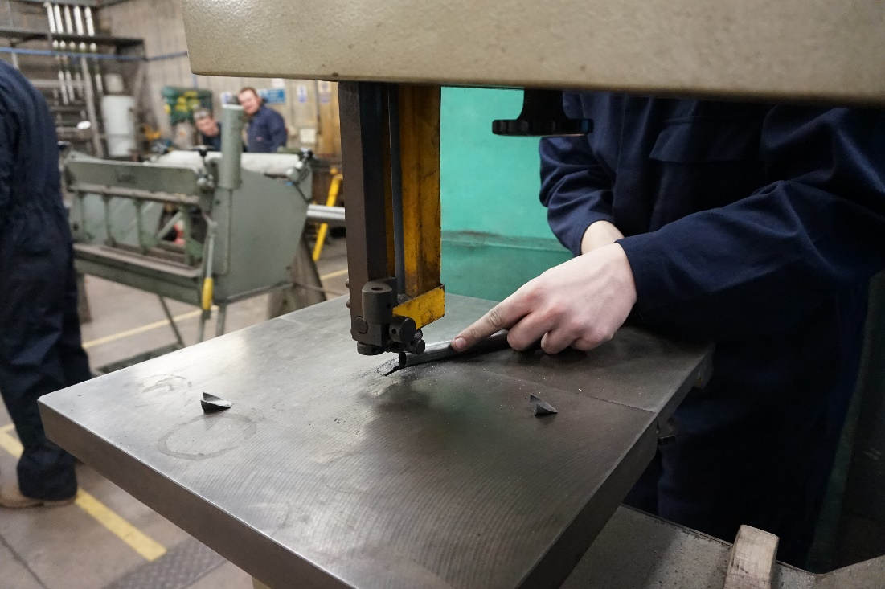
This picture shows one of the ream cutting materials to length.
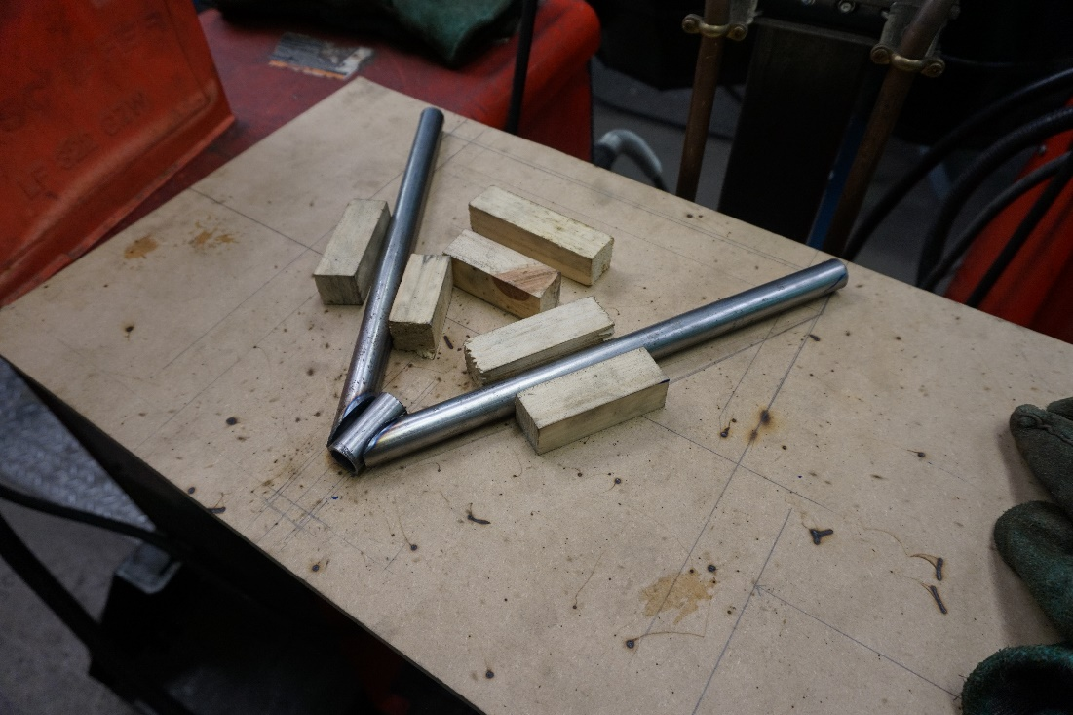
The above picture shows the jig that was used to ensure the wishbones would not get deformed when welding. This jig also held the components together for welding.
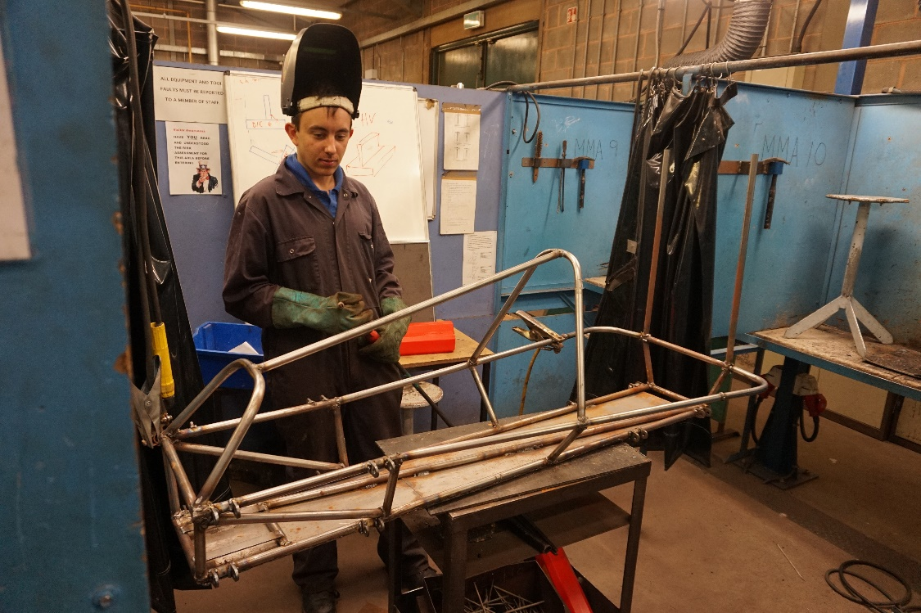
The above image shows Jordan Powell welding the chassis of the cart.
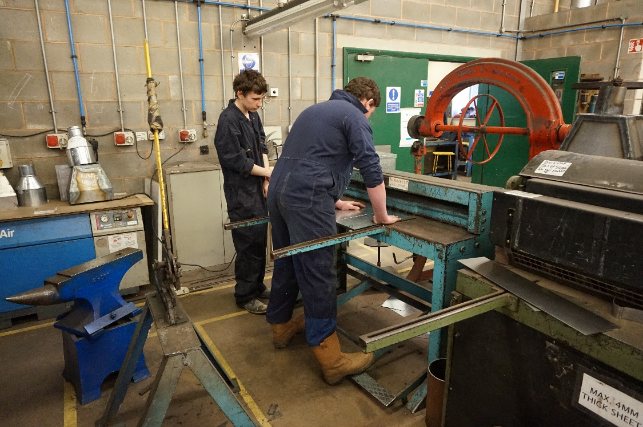
This picture shows Jake and Tom D cutting sheet metal to lengths for manufacturing.
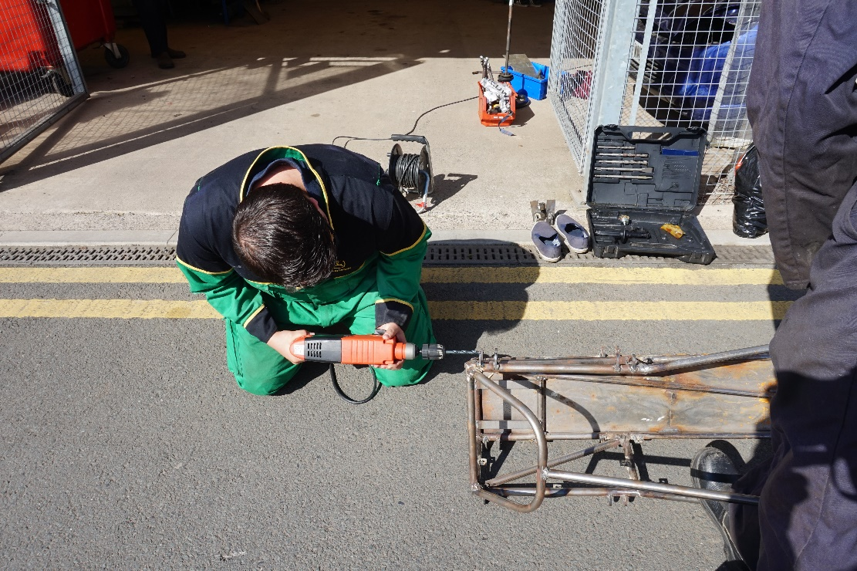
This image shows myself drilling some of the mounting points which were too small for the bolts and rose joints.
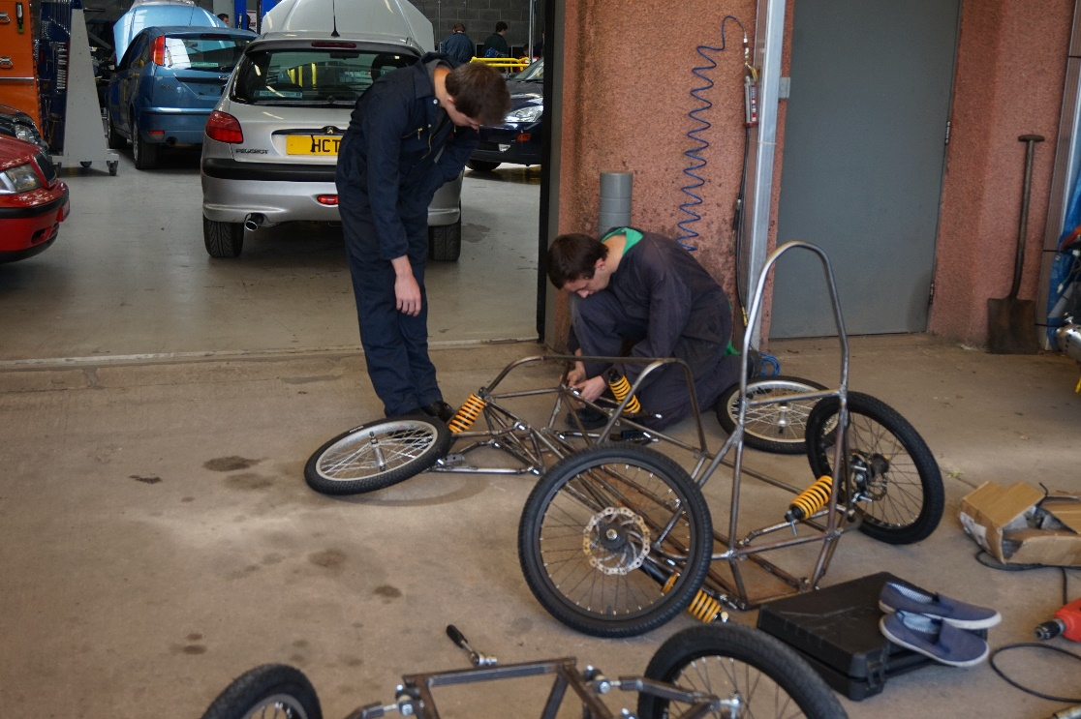
The above image shows Jordan assembling together the front suspension.
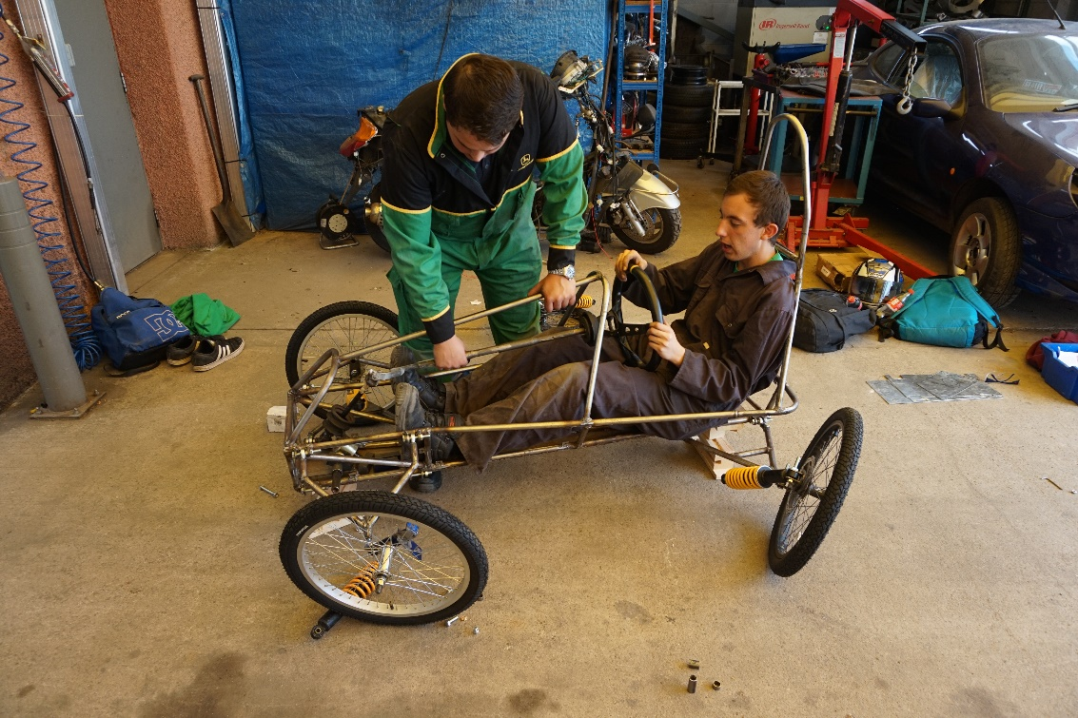
The final image that I have chosen to use shows myself and Jorden testing the steering system ensuring that it fits and linens up properly.

All of the above pictures were taken by course tutor Anthony King throughout the project.

